c:Composite

shape: Circle

ALT

circleClicked()

state=BOX

boxClicked()

user

state=CIR

shape: Box

:HW1Controller

:HW1GUI

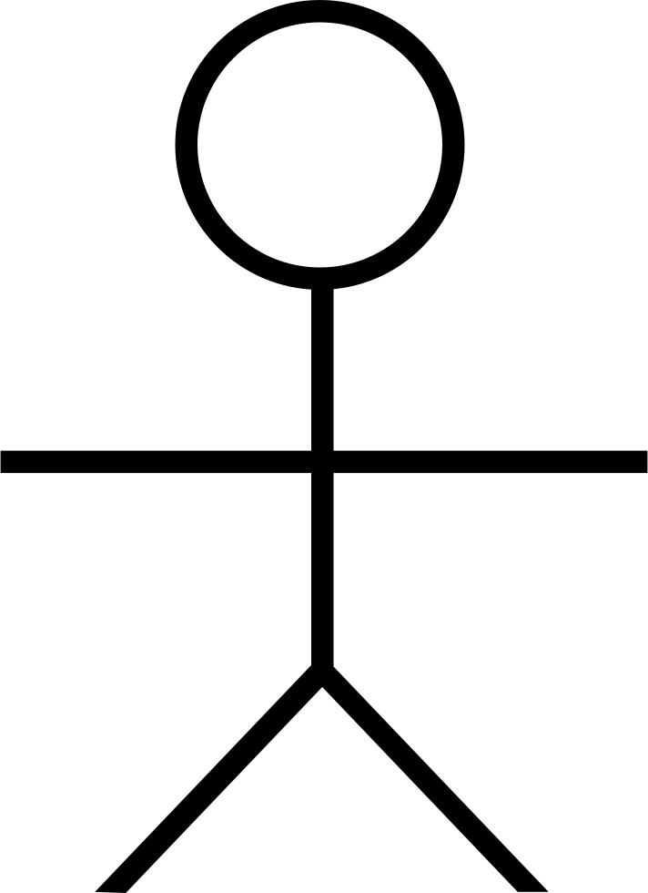

<<button/

canvas

clicked>>

Iterator it=collection.iterator();

while (it.hasNext()) {

((Shape)it.next()).draw(g);

}

repaint calls Canvas'

paintComponent(g:Graphics), which

calls Composite's draw(g:Graphics).

draw(g:Graphics)

repaint()

c:=getComposite():

Composite

[state==CIR]

[state==BOX]

add(shape)

create(p:Point)

ALT

canvasClicked

(p:Point)

create(p:Point)